**PROJECT REPORT**

**World’s Subscribers Galore: Exploring Top Youtube Channels**

**NM ID: NM2023TMID15331**

1. **INTRODUCTION**

Overview

* The overview section provides a broad look at the YouTube ecosystem, discussing the evolution of YouTube, its user demographics, and the various types of content available on the platform. It may touch on the diversity of channels, from vlogs and gaming to educational content and entertainment.

Purpose

* The purpose of the study is to analyze and showcase.

**2.Problem Definition & Design Thinking**

Empathy Map

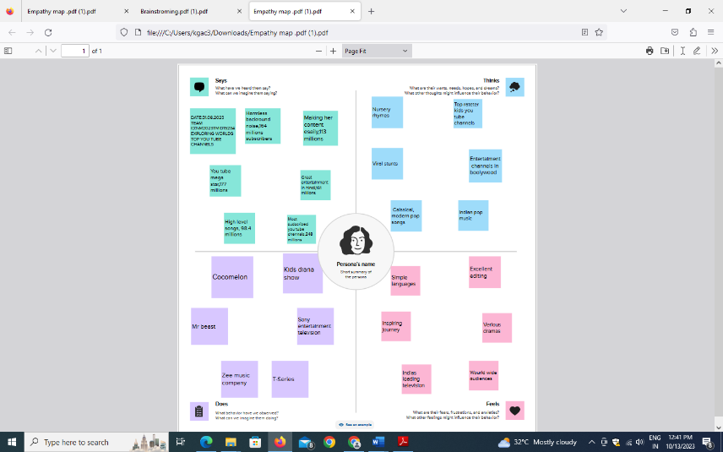

Ideation & Brainstorming Map

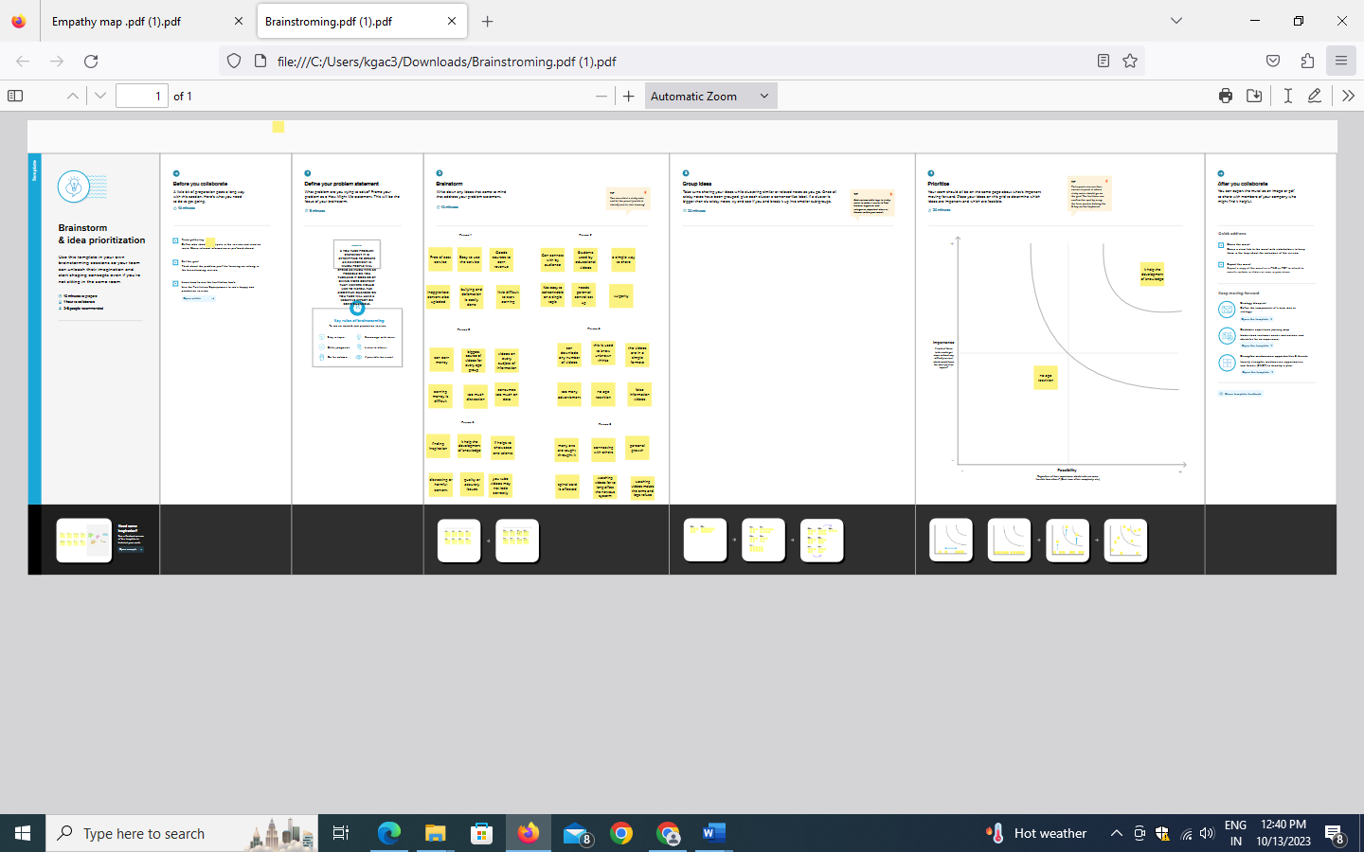

**3.RESULT**

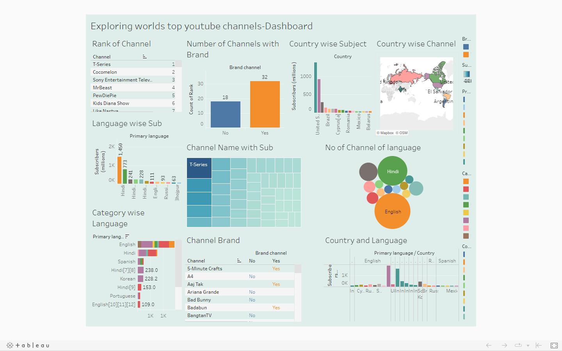

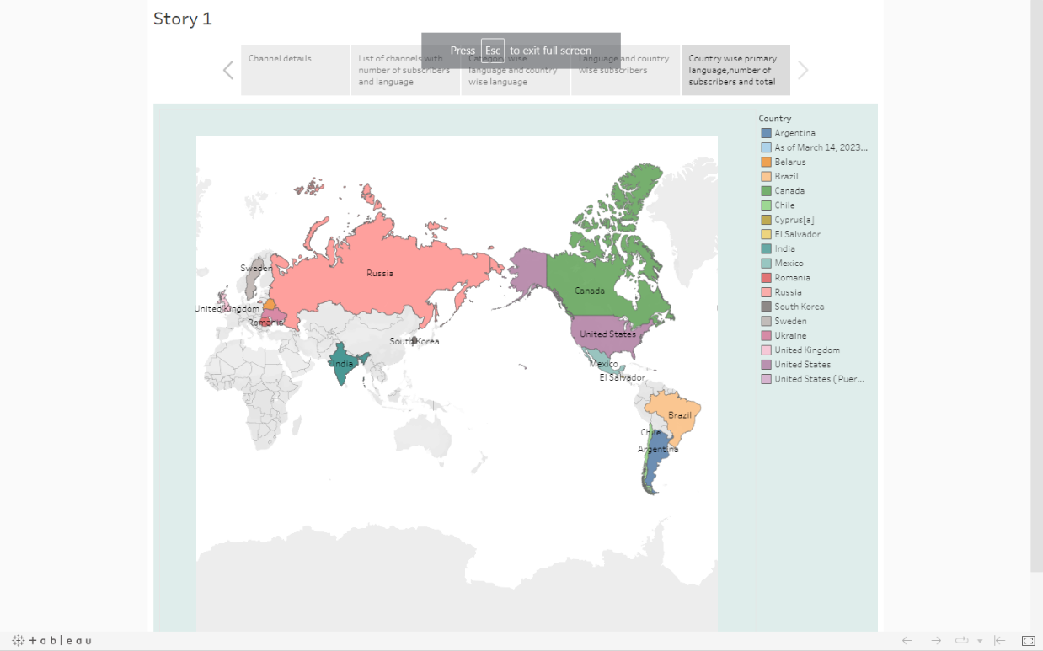

**4.ADVANTAGE AND DISADVANTAGE**

Advantages:

* More subscribers can lead to higher visibility for your content as they are notified when you upload new videos.
* With a substantial subscriber base, you can monetize your channel through ads, sponsorships, and merchandise.
* Subscribers often form a community around your content, which can lead to engagement, discussion, and loyalty.

Disadvantages:

* With more subscribers there’s pressure to consistently produce high-quality content, which can be stressful and time-consuming.
* Subscribers may have specific expectations, and deviating from your usual content may lead to disappointment.
* As your channel grows, managing comments and dealing with potential negativity can become challenging.

**5.APPLICATIONS**

* Marketing and Promotion
* Content Creators
* Influencer Marketing
* Branding and Visibility
* Monetization

**6. CONCLUSION**

* In this analysis of the world’s top YouTube channels, we examined various metrics including subscriber counts, video views, and content categories. We found that channels in the entertainment and music categories dominate the platform, with notable channels such as T-series and Cocomelon boasting the highest number of subscribers. Additionally, we observed a strong correlation between engaging content and a channel’s subscriber growth. The study also highlighted the importance of consistent content creation and audience engagement strategies for YouTube success.

**7.FUTURE SCOPE**

* Top channels may diversify their content to reach a broader audience. For example, a gaming channel might expand into other forms of entertainment of lifestyle content.
* As YouTube continues to evolve, channels may explore new ways to monetize their content. This can include merchandise sales, exclusive content for subscribers, or brand partnerships.
* AI and machine learning could play a role in content creation and recommendations, helping creators optimize their content and engage with their audience more effectively.